A physiological time series of thermal limits reveals substantial acclimation capacities under natural conditions in the Lake Champlain calanoid copepod community

Matthew Sasaki1,2, Aly Rodger1, Chanchal Saratkar1, Jamie Cull-Host1, Sydney Sharp1, Yuuki Real1, Melissa Pespeni1

1. University or Vermont, Department of Biology
2. University of Massachusetts Lowell, Department of Biological Sciences

Abstract

Populations are exposed to temperature variation over different timescales. By shaping their relative vulnerability to warming, but acclimation capacity could shape both population and community responses to climate change. Variation in acclimation capacity across community members under natural conditions is rarely measured, however, leading to uncertainties about the role of acclimation. Using a weekly physiological time series we examined seasonal variation in upper thermal limits for the entire community of calanoid copepods in Lake Champlain, a large and highly seasonal lake in North America. Thermal limits varied substantially between species, with winter-dominant species having lower thermal limits than summer-dominant species. Our high-resolution temporal data also revealed substantial but variable acclimation capacities across community members. Over the course of our collections, we also observed the presence of two novel species occurrences in Lake Champlain, both of which were notable for their high upper thermal limits. Our results highlight the important role acclimation plays in how shaping populations responses to temperature variation under natural conditions.

# Introduction

Predicting the effects of climate change on biodiversity is a pressing challenge. Faced with rapid warming across lakes and standing waters in many regions (Woolway et al. 2020; Kraemer et al. 2021), freshwater aquatic organisms may be particularly vulnerable to anthropogenic changes (Sayer et al. 2025). As temperatures increase, there have been widespread observations of shifts in community composition, population abundances, and range distributions across many taxa (Khaliq et al. 2024). Diverse physiological and ecological mechanisms may underlie these changes, but variation in thermal performance traits (and upper thermal limits in particular) across taxa has received particular attention (Roeder et al. 2021; Calosi et al. 2007), and spatial patterns in thermal limits are often used to predict patterns in vulnerability to climate change (Pinsky et al. 2019).

Many of these studies assume, however, that thermal limits are invariant within species. A growing body of literature shows this is clearly not the case. Local adaptation (Sasaki et al. 2022) and acclimation (Morley et al. 2019) can produce substantial intraspecific variation in thermal limits that is important to consider for robust predictions about the effects of climate change on biodiversity (Jacob and Legrand 2021). Population responses to temperature seasonality can also entail substantial shifts in organismal performance (Huey and Buckley 2022; Leclair et al. 2020; Harada et al. 2018; Hahn and Brennan 2024; Garton et al. 1990). Importantly, both adaptation and plasticity may play important roles in shaping how populations of short-lived taxa cope with seasonally varying temperatures (Hahn and Brennan 2024; Ueno et al. 2023; Sasaki and Dam 2020; Bergland et al. 2014; Rudman et al. 2022). This temporal variation in thermal limits may mediate vulnerability to both acute and long-term warming events (Dowd and Denny 2020). Understanding the extent to which populations rely on these different mechanisms to persist in variable environments can provide key insights into how long-term climatic changes may affect biodiversity.

While highly controlled laboratory experiments can provide crucial mechanistic insight into seasonal variation in thermal limits (i.e. is variation genetic or plastic in origin?), assessments under more realistic conditions are also needed. The idealized, stable conditions and experimental designs typically used in laboratory environments may, for example, mask how other factors like food limitation, behavioral thermoregulation, photoperiod, humidity, etc. influence thermal limits in natural populations (Ueno et al. 2023). Laboratory estimates of the effects of plasticity are also subject to a number of potential methodological artifacts (Rohr et al. 2018). Given the important (but uncertain) role plasticity may play in mediating vulnerability to warming (Seebacher et al. 2015; Morley et al. 2019; Gunderson and Stillman 2015), we need to complement laboratory studies with a better understanding of potential constraints on thermal limits and the effects of plasticity under realistic environmental conditions. These constraints (including natural seasonal variation in organismal condition) may be particularly important for contextualizing environmental stress (Dowd and Denny 2020) and grounding predictions about how interactions between plasticity and adaptation may shape population responses in a changing climate (Diamond and Martin 2016; De Lisle and Rowe 2023).

Further, while describing seasonal variation within a single species can provide useful insights, variation in both thermal limits and acclimation capacity across community members will likely play a major role in determining ‘winners and losers’ in a changing climate (Somero 2010; Roeder et al. 2021). These dynamics are important to understand in order to predict how climate change may alter ecological dynamics at a larger scale. Despite this, very few studies have examined in situ, seasonal patterns in thermal limits across community members, limiting our ability to compare the effects of acclimation. Those that have (Bujan et al. 2020; Oliveira et al. 2021; Haque et al. 2025; García et al. 2024; Redana et al. 2024; Hu and Appel 2004; Houghton and Shoup 2014; Hopkin et al. 2006) have found variable magnitudes of variation in thermal limits, which often translates to variable acclimation capacity across community members. These studies have, however, tended to focus on a small number of community members, just a portion of the annual temperature cycle, or have covered the entire year with fairly course (i.e. monthly) sampling intervals. This has led to a general need for a better understanding of the biological processes that affect winter active species, especially in aquatic taxa (Dinh et al. 2023; Hampton et al. 2017; Pu et al. 2025), and a limited understanding of how variation in physiological thermal limits affects ecological patterns like seasonal community turnover, long-term shifts in community composition and changes in phenologies observed in various aquatic systems (Corona et al. 2024; Khaliq et al. 2024). A high temporal resolution, community-wide examination of acclimation under natural conditions, spanning the full annual temperature cycle, may help to establish a mechanistic foundation for understanding population responses to changing seasonality (Hernández-Carrasco et al. 2025; Williams et al. 2017).

Planktonic copepods are a useful model system for studying variation in thermal limits and acclimation capacity. These taxa are widespread, diverse, and abundant throughout the year in many freshwater systems. This group is also ecologically important, as grazers of phytoplankton and microzooplankton and prey for early life stages of many fish species. While historically thermal limits and acclimation capacity in freshwater copepods have been largely overlooked (Sasaki and Dam 2021), there has been renewed interest in these systems (Nowakowski and Sługocki 2024; Bonadonna et al. 2025). Here we examine seasonal patterns in upper thermal limits of the entire calanoid copepod community in Lake Champlain, a large, highly seasonal lake in temperate North America. Sampling at approximately weekly intervals, we generated a physiological time series to examine both across and within species variation in thermal limits, and examine whether these differences may contribute to seasonal changes in copepod community composition. We also use this high resolution data set to quantify species-specific acclimation capacities under natural conditions.

# Methods

### Field Collections and Environmental Data

Plankton were collected within the top three meters of Lake Champlain (coordinates: 44.481149, -73.225451) with a combination of horizontal and vertical tows of a 500 um mesh plankton net. These collections were not intended for quantitative measurement of abundance, so the precise volume of water filtered was not tracked. Surface water temperature was measured at the time of collection using a handheld thermometer. Plankton were transferred to an insulated flask and immediately transported to the laboratory at the University of Vermont, where the tow contents were divided among several 500 mL beakers and placed in a benchtop incubator (IVYX Scientific) set to the temperature recorded at the time of collection. The USGS maintains a continuous temperature record at a nearby site (~650 meters from our sampling site; coordinates: 44.47616017, -73.2215166), which allowed us to examine more fine-scale patterns across the entire collection period for this project (2023-05-25 to 2024-05-20). Temperatures recorded at the time of collection closely matched the maximum daily temperatures from the continuous temperature record (Supp. Fig. 1).

### Trait Measurements

Thermal limits were measured as the critical thermal maximum (CTmax), the temperature at which an individual no longer responded to stimuli (i.e. onset of heat coma), using a previously developed method (Sasaki et al. 2023). The experimental set-up includes a reservoir containing a heating element and two aquarium pumps, a plexiglass water bath, and a continuous temperature recorder. One aquarium pump circulates water within the reservoir, while the other pumps water into the water bath. The water bath contains thirteen 50 mL flat-bottom glass vials, each with 10 mL of bottled spring water. Small temperature sensors connected to an Arduino logger were placed into three of these vials. Temperature was recorded every five seconds during the experimental assays. To begin each CTmax assay, the water in the reservoir was adjusted to match the collection temperature using either the heating element or by adding ice. When the water bath was holding steady at the collection temperature, calanoid copepods were sorted from the bulk plankton tow contents and placed individually into the remaining ten vials. After all vials were filled, copepods were given a 15 minute resting period, then the heating element was turned on to initiate the temperature ramp. Individuals that were not active after this resting period were excluded from the assay. The rate of temperature increase was 0.3°C per minute at the beginning of the assay, and gradually decreased to ~0.1°C per minute. Individuals were monitored continuously during the ramp until normal movement ceased and the individual no longer responded to gentle stimulus (slight water movement generated by turning the vials). The time at that point was recorded and the vial removed from the water bath. The continuous temperature record from the Arduino loggers was used to determine CTmax based on these recorded times. After all individuals had reached their CTmax, the copepods were transferred to the lid of a 96 well plate and examined using a stereoscope (Olympus SZX7). Individuals were identified to the species level (LaMay et al. 2013; Ward and Whipple 1959), and categorized as either male, female, or juvenile. For females bearing egg sacs, clutch size (the number of eggs contained) was also recorded. Finally, each individual was photographed along with a scale micrometer for body size measurements. Body size was measured using ImageJ (Schindelin et al. 2012) as prosome length. After the entire data set was collected, these images were also re-analysed to identify three other potential traits of interest (the presence of developing eggs, the presence of lipid droplets, and visually apparent internal parasites or pathogens). There were several diverse pathogen classes observed throughout the season. Since specific identification was not possible from the images, we grouped these pathogen phenotypes into three visual classes, a ‘spot’ phenotype, a ‘cloudy’ phenotype, and an ‘other’ group that contained the remaining individuals (Supp. Fig. 2). Identification of the pathogenic species / physiological processes underlying the infection was not possible with our photo-based approach, but this analysis provides preliminary evidence of which pathogen classes may impact these copepod populations, which can be followed up with more targeted mechanistic investigations (Eliassen et al. 2024). These additional traits were scored by a single individual to ensure consistency across the entire set of samples.

### Data Analysis

All analyses were conducted with R version 4.1.3 (Team 2022). We used a linear mixed effects model to examine the influence of species, collection temperature, and individual sex on CTmax. All interactions were included in this model. Temperature was centered but not scaled before analysis. Since CTmax assays were often performed over the course of several days after collection, we included the number of days copepods spent in the lab before CTmax was measured as a random effect. The species-specific acclimation response ratios (ARR) were estimated from this initial model as the marginal mean of the linear trend (emmeans package; Lenth 2025). The relationship between a species’ mean CTmax and the estimates of ARR obtained here were compared against a collection of estimates from a previous data synthesis on copepod thermal limits (Sasaki and Dam 2021). For the three diaptomid species (*Skistodiaptomus*, *Leptodiaptomus minutus*, and *L. sicilis*) the residuals from this model were regressed against clutch size to examine potential fitness costs associated with increased thermal limits. It was not possible to examine fecundity for the remaining four species, which release their eggs directly into the water column. A secondary model including data just for females examined the effect on CTmax of species and collection temperature (with their interaction), along with the presence of developing eggs, the presence of lipid droplets, and the presence of potential pathogens.

We also used two approaches to examine the potential environmental drivers of acclimation. First, we examined the correlation between CTmax and a number of predictors (the overall mean, median, minimum, and maximum temperature; the mean daily minimum, maximum, and range; and the temperature range and variance) calculated for periods of time ranging from 1 to 60 days before collection. This analysis is largely speculative, so we identified the top predictor-duration combination for each species based on the maximum correlation coefficient between the predictor and CTmax values. For two species, *Leptodiaptomus minutus* and *L. sicilis*, that appear to acclimate rapidly to changes in temperature (i.e. the temperature measured at the time of collection was the best predictor), we also used a distributed lag non-linear model to examine potential timescales of this rapid response (Redana et al. 2024). This approach examined how the magnitude and timing of fluctuations in temperature over the 200 hours prior to collection, based on the USGS continuous temperature record, affected organismal thermal limits.

# Results

## Community composition

Our weekly sampling method yielded thermal limit data for all six species of calanoid copepods observed in Lake Champlain - *Skistodiaptomus sp.*, *Leptodiaptomus minutus*, *L. sicilis*, *Epischura lacustris*, *Senecella calanoides*, and *Limnocalanus macrurus*. We also collected a single individual of *Osphranticum labronectum* in early October 2023 - to our knowledge, this is the first observation of this species in Lake Champlain. There is also some uncertainty regarding the *Skistodiaptomus* species we collected. In Lake Champlain, this has historically been identified as *Skistodiaptomus oregonensis* (LaMay et al. 2013), but a small number of individuals we collected in Summer 2024 were identified as *S. pallidus* via genetic barcoding (Cytochrome oxidase I) as part of a separate project. *S. pallidus* does occur in nearby water bodies (Chiapella et al. 2021), and has previously been noted for its potential to invade Lake Champlain from adjacent water bodies (Malchoff et al. 2005). As we did not preserve material from our CTmax assays and it is not possible to differentiate these two species in the images taken, we will refer to *Skistodiaptomus sp.* throughout this study. We acknowledge that the data reported is likely for a combination of the two species. Finally, for one of the winter species, *L. sicilis*, we detected the presence of two distinct size morphs (Supp. Fig. 3). Dissection of individuals from both morphs confirmed species identity (Ward and Whipple 1959); instead, the presence of these distinct size classes likely indicate the transition between different generations in the population (Lai 1977; Herzig et al. 1980).

## Seasonality, Phenology, and Thermal limits

Surface temperatures measured at the time of collection ranged from 2.5°C to 26.5°C during the sampling period, which included 48 unique collection events (Fig. 1). We measured a total of 1312 individual thermal limits during this period. The number of thermal limits varied across species, ranging from a minimum of 42 for *Senecella calanoides* (not including the single *Osphranticum* individual) to a maximum of 482 for *Leptodiaptomus sicilis* (Table 1). While our sampling approach precludes quantitative estimates of abundance, the number of CTmax measurements made for each species does qualitatively reflect their relative abundance in the samples collected.

Table 1 - Samples sizes for each of the seven species examined in this study.

| Species | CTmax Measurements |
| --- | --- |
| *Osphranticum labronectum* | 1 |
| *Senecella calanoides* | 42 |
| *Limnocalanus macrurus* | 86 |
| *Epischura lacustris* | 102 |
| *Skistodiaptomus sp* | 275 |
| *Leptodiaptomus minutus* | 324 |
| *Leptodiaptomus sicilis* | 482 |

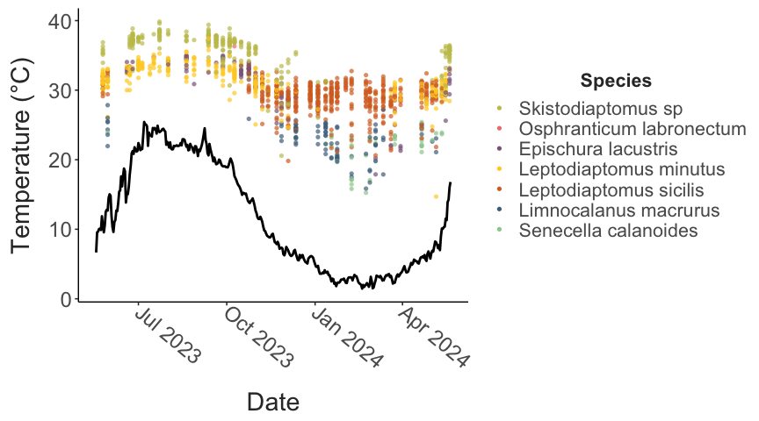

Figure 1 - Seasonality in CTmax and lake surface temperature. Individual CTmax measurements are shown as points, with the different species shown in different colors. Lake surface temperature from a USGS continuous temperature sensor is shown with the solid line.

The calanoid copepod community could be divided into a Summer-Fall group (*E. lacustris*, *Skistodiaptomus sp.*, and *L. minutus*) and a Winter-Spring group (*S. calanoides*, *Limnocalanus macrurus*, and *L. sicilis*) (Fig. 2a). The Summer-Fall group is characterized by smaller body size and higher thermal limits, while the Winter-Spring group included species with both small and large body sizes, but lower thermal limits (Fig. 3). *O. labronectum* had a relatively high upper thermal limit (36.3°C), and groups with the Summer-Fall assemblage. With only a single observation, however, this affinity is tentative. Across all species, CTmax increased with increasing collection temperatures (discussed more in the following section; Fig. 2b). Despite this, warming tolerance (the difference between CTmax and collection temperature) decreased with increasing collection temperatures for all species, suggesting increasing vulnerability at higher temperatures in both assemblages (Fig. 4a).

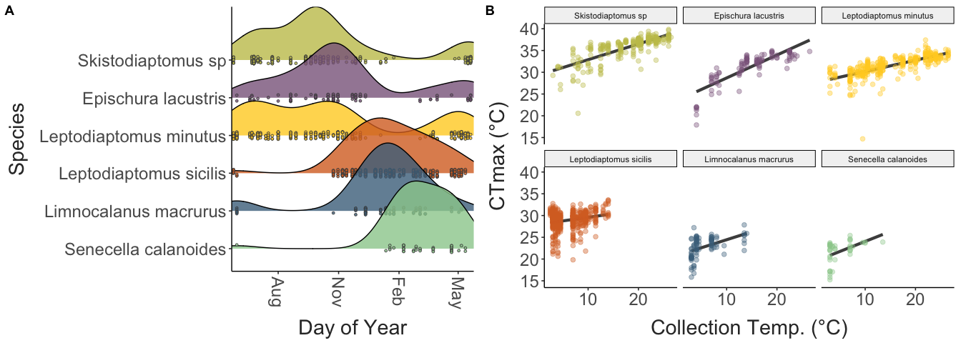

Figure 2 - The seasonal occurrence of the six major species of calanoid copepods in Lake Champlain are shown in Panel A as a ridge plot, visualizing the temporal distribution of CTmax measurements for each species. The relationship between CTmax and the surface temperature recorded at the time of collection is shown in Panel B. CTmax values for each species are shown separately, along with a linear regression describing the relationship between measured thermal limits and collection temperature.

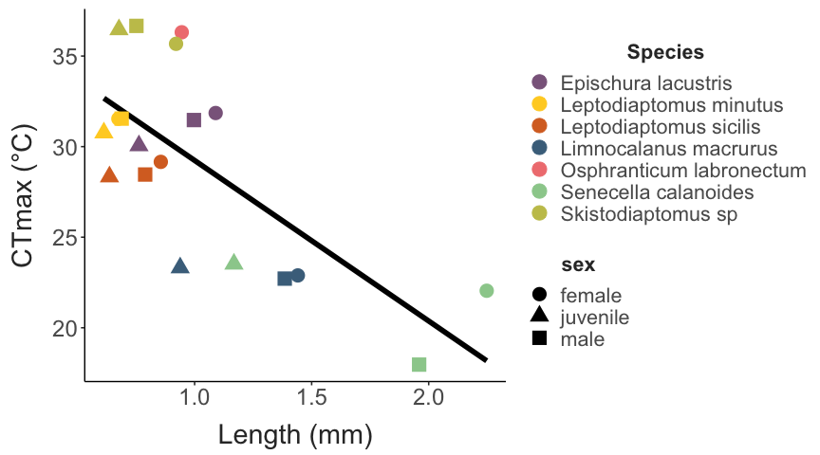

Figure 3 - CTmax tends to decrease with increasing size. Mean values for both CTmax and size (measured as prosome length) are shown here for male, female, and juvenile individuals from each species.

Clutch size was not related to collection temperature in the two *Leptodiaptomus* species, but increased with collection temperature in the *Skistodiaptomus sp.* (Fig. 4b). Clutch sizes tended to increase with female body size in *Skistodiaptomus sp.* and *L. minutus*, but not in *L. sicilis* (Fig. 5a). There were no strong relationships between CTmax residuals and clutch size in any species, indicating that increases in thermal limits were not influenced by a trade-off with reproductive output (Fig. 5b).

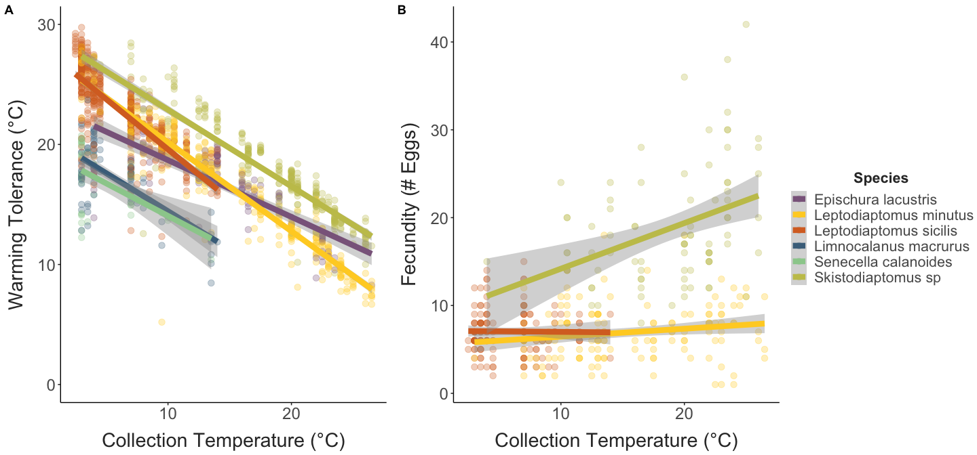

Figure 4 - Observed values for warming tolerance (Panel A) and egg clutch size (Panel B) plotted against collection temperature. Each point represents an individual measurement, with different species shown in different colors. A regression line is included for each species.

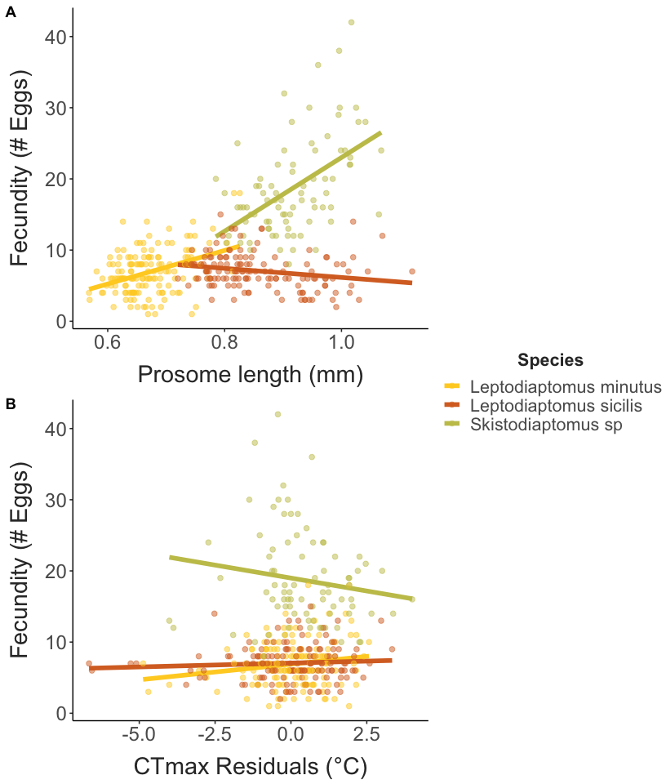

Figure 5 - The relationships between fecundity (measured as clutch sizes) against collection temperature (Panel A) and thermal limit residuals (Panel B). CTmax residuals show variation in CTmax after controlling for the effect of collection temperature. Data is only shown for the three egg-sac bearing species in the data set.

The second model examined the effect of developing eggs, lipid reserves, and visible pathogens on female CTmax. Model selection indicated no change in model fit when the presence of developing eggs and the presence of lipid droplets were removed as factors. Analysis of just the model including species, collection temperature, their interaction, and the presence of visible pathogens indicated a significant effect of pathogen presence on female CTmax. Estimated marginal means for the three different pathogen classes indicates variability in the effect on CTmax relative to individuals without visible pathogens (Supp. Fig. 4). There was no change in CTmax in individuals exhibiting the ‘spot’ phenotype whereas copepods exhibiting phenotypes in the other two classes exhibited a decrease in CTmax of ~2°C, although the effect of the ‘other’ pathogen class had a large estimated standard error.

## Acclimation Responses, Drivers, and Timescales

While CTmax increased with increasing collection temperature for all species, species-specific ARR estimates (change in CTmax per degree change in collection temperature) varied in magnitude from 0.14 to 0.77 (*L. sicilis* and *S. calanoides*, respectively). The magnitude of the ARR estimates tended to decrease with increasing average thermal limits, mirroring the pattern observed across other copepod taxa (Fig. 6). Note, the estimates of ARR from Sasaki and Dam (2021) are based on a data synthesis approach, and 1) exclude a single polar genus with a large negative ARR, and 2) examine variation in thermal limits at the genus level. Patterns were, however, qualitatively the same at the population, species, and genus level (Sasaki and Dam 2021).

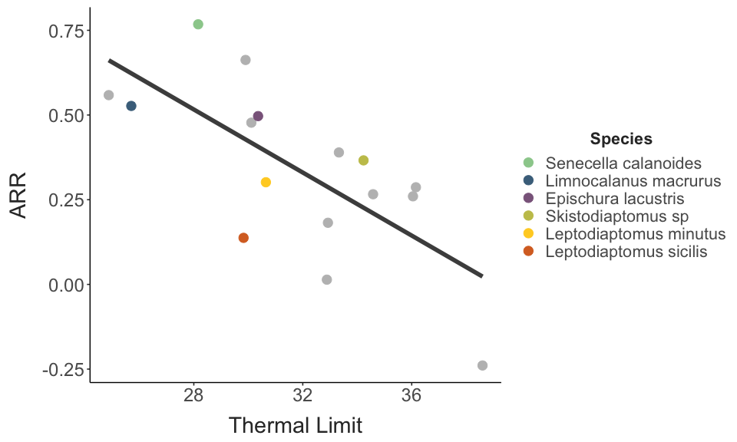

Figure 6 - The negative relationship between Acclimation Response Ratios and upper thermal limits. Values from Lake Champlain species measured in this study are shown in color, while values from a recent data synthesis study (Sasaki and Dam 2021) are shown in grey.

The ARR estimates above are based on the relationship between collection temperature and CTmax. We also examined more specific potential drivers of acclimation responses (Fig. 7). For three of the species (*Epischura lacustris*, *Senecella calanoides*, and *Skistodiaptomus sp.*), CTmax was most strongly correlated with the maximum temperature. CTmax was most strongly correlated with minimum temperature for *Limnocalanus macrurus*. The two *Leptodiaptomus* species had CTmax values that were most strongly correlated with collection temperature. There was also substantial variation in the duration of time that best explained CTmax variation, ranging from an almost 30 day period in *Epischura lacustris* to <1 day in the two *Leptodiaptomus* species. We note, however, that for all species except *Senecella calanoides* the difference in correlation coefficients between the strongest predictor and collection temperature were negligible (Fig. 7).

The two *Leptodiaptomus* species present in Lake Champlain both appear to adjust CTmax rapidly, with CTmax most closely correlated with temperature at the time of collection. We used a distributed lag non-linear model to examine the potential timescales of this rapid acclimation. For both species, these models indicated acclimation to short-term deviations (spikes or drops in temperature) occurring during the 200 hours leading up to collection, with the change in CTmax depending on both the magnitude of the deviation and the timing (Supp. Fig. 5). Large deviations (+4°C or -4°C) during the two days leading up to collection increased or decreased CTmax by ~0.5°C, respectively. The effect of these large deviations diminished as timing prior to collection increased. The effect also decreased as the magnitude of deviation decreased - changes of +/- 1°C had only minor effects on CTmax even when the deviation occurred near the time of collection.

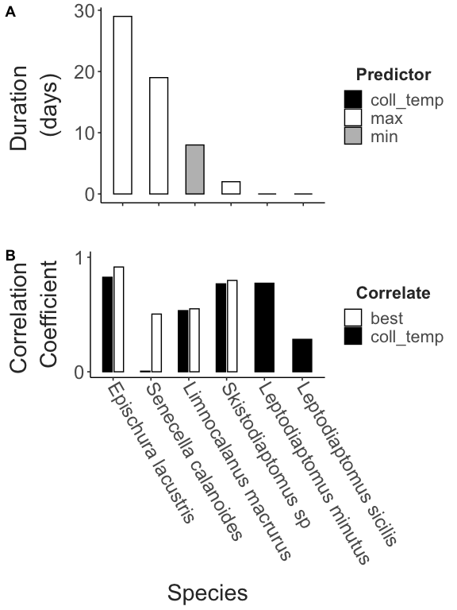

Figure 7 - Panel A - The duration of potential acclimation periods (days prior to collection) shown for each of the species. Bar fill color indicates the potential cue (collection temperature, maximum temperature during the acclimation period, or minimum temperature during the acclimation period). Panel B - The observed correlation coefficients between the best predictor (white bars) and the temperature measured at the time of collection (black bars).

# Discussion

We examined seasonal variation in the upper thermal limits of the community of calanoid copepods in Lake Champlain. Samples cover the entire annual temperature range, revealing substantial variation in thermal limits between the seasonal community assemblages. High frequency sampling also enabled us to examine within-species variation in thermal limits, estimating the acclimation capacity under natural conditions for the community of calanoid copepods. Taken together, we show that species most abundant in the winter have lower thermal limits than those present during the summer, and that acclimation has a significant but variable effect on thermal limits across the entire community. Based on measurements under natural conditions, our results reinforce that temporal variation in thermal limits can mediate population vulnerability to warming, and that at the community level, variation in both thermal limits and acclimation capacity are important factors to consider when assessing ecological vulnerability.

The fairly intensive sampling regime we employed had clear benefits, capturing data for all species of calanoid copepods previously reported in Lake Champlain, with additional observations of potentially newly introduced species. One of these novel species, *Osphranticum labronectum*, is widely distributed throughout freshwater systems across North America, with a range extending from Central America into Canada (Gutierrez-Aguirre and Suárez-Morales 1999). This broad distribution suggests this species is able to tolerate a wide range of conditions, although the role of local adaptation is unknown. The data point we’ve collected (for whatever a single measurement is worth), suggests a relatively high upper thermal limit, with a higher CTmax value than all but one other species in Lake Champlain. As lakes in the temperate regions of North America continue to warm, this species may become increasingly abundant at higher latitudes. In addition to the observation of *O. labronectum*, we also found evidence for the presence of *Skistodiaptomus pallidus* in Lake Champlain. *S. pallidus* is comprised of multiple divergent mitochondrial lineages (Thum and Derry 2008). The lineage we observed is widespread in the Eastern US, and is known to be invasive in freshwater systems in New Zealand, Mexico, and Germany (Branford et al. 2017). What proportion (if any) of the *Skistodiaptomus* individuals we examined belong to *S. pallidus* as opposed to the historically dominant *S. oregonensis* we are unable to determine. A targeted study combining COI barcoding with individual thermal limits could disentangle any species-specific patterns in CTmax and examine the realized seasonal/thermal niche of *S. oregonensis* and *S. pallidus* in Lake Champlain, providing insights into invasion dynamics with congeneric species. It’s worth noting that both novel observations (*O. labronectum* and *S. pallidus*) appear to have the highest thermal limits of the calanoid species in this community - high upper thermal limits may play a role in the success of invasive or newly introduced species (Kelley 2014). It would be interesting to compare upper thermal limits for notable invasive calanoid copepod species in other regions (e.g. *Arctodiaptomus dorsalis*, *Pseudodiaptomus marinus* and *P. forbesi*, and *Sinodiaptomus sarsi*; Svetlichny and Samchyshyna (2021); Reid (2007); Uttieri et al. (2020); Orsi and Walter (1991)) with those of the copepod communities in their native and invaded ranges.

At the community level, the data presented here highlights clear differences in thermal limits of the seasonal assemblages of calanoid copepods in Lake Champlain. Differences in CTmax may be informative about long-term trends in competitive interactions (Martin and Ghalambor 2023) and abundance under warming (Roeder et al. 2021). If, as in other systems (Fitzgerald et al. 2021), the winter-active species are most vulnerable in warming climates (due to low thermal limits), we might expect significant changes in the ecology of Lake Champlain and similar systems. The winter-active species tend to be relatively large and lipid rich (Vanderploeg et al. 1998; Cavaletto et al. 1989) and play diverse ecological roles (e.g. grazing on phytoplankton and microzooplankton, along with predation on other zooplankton). Loss of these species would have profound effects on the food web structure of this system. However, while there have been large changes in the abundance of calanoid copepods in Lake Champlain over the past decades (Mihuc et al. 2012), the patterns we observed here suggest that the copepod populations are not directly limited by temperature. While thermal limits of the Winter-Spring assemblage of copepods were substantially lower than those of the Summer-Fall assemblage, warming tolerance (the difference between thermal limits and environmental temperatures) was always greater than 10°C, even during the transition between assemblages. Over longer timescales, this suggests substantial warming would be required before reductions in population abundance via direct effects of temperature (e.g. via increased mortality rates). Other environmental factors (food abundance, light levels, predator abundance, etc.) or indirect effects of temperature (e.g. effects on reproduction, water column stratification and changes in phytoplankton community composition, shifts in competition with summer-dominant species) seem to have a larger effect on seasonal succession, and may mediate both phenological and long-term shifts in the dynamics of this system. As a metric, however, CTmax can be difficult to directly link to patterns in temperature-driven mortality in the field; instead it may be more useful to generate ‘thermal tolerance landscapes’ for these species (Rezende et al. 2014), in order to better understand the degree to which temperature directly limits population occurrences (Rezende et al. 2020).

Also important for making robust predictions about the role of acclimation in shaping responses to warming is identifying the environmental driver of acclimation responses (Dowd and Denny 2020). The experienced thermal environment can be complex, with contrasting temporal patterns in the mean or maximum as opposed to the range or amount of variability. Our results suggest that different cues over different time spans drive the patterns in thermal acclimation we observed. Across the species we examined, thermal limits correlated with different aspects of the thermal environment (e.g the minimum or maximum temperatures) over timescales from less than one to thirty days. For the two *Leptodiaptomus* species, which appear to acclimate most rapidly, distributed lag non-linear models suggest responses to temperature variation on the order of hours. These drivers and time spans provide hypotheses that can be tested in laboratory acclimation experiments (Kraskura et al. 2024), but already point to the importance of understanding the species-specific drivers of acclimation in order to accurately predict the role of plasticity in mediating vulnerability over short and long timescales. Interestingly, our results indicate aspects of temperature variability (range, variance, etc) are not the primary drivers of acclimation in these copepods. Similar results were obtained for another freshwater calanoid in a set of mesocosm experiments (Bonadonna et al. 2025). These manipulative experiments balance experimental feasibility and environmental realism (Sasaki, Isanta-Navarro, and Govaert 2025), and may play a large role in testing both species- and community-level hypotheses about the interactions between environmental variation and plasticity.

While lacking the kind of mechanistic insights gained from highly controlled laboratory experiments, the relatively fine temporal scale of the data on thermal limits and seasonal occurrence we collected highlights the complex interactions between species’ life history, ecology, acclimation, and adaptation that may ultimately shape the response of these taxa to long-term climate change in natural systems. Temperature, for example, has strong effects on copepod body size (Campbell et al. 2021). Many key physiological and life history traits correlate with body size in copepods, and as a result the effects of warming will reflect interactions between the impacts of acclimation and changes driven by size-scaling effects (Riemer et al. 2018). Further, the relative impacts of these two effects can change across generations (Juan et al. 2023), making it difficult to predict long-term responses.

Temperature also has strong impacts on copepod generation times (Mauchline 1998; Winder et al. 2009). A warming-induced increase in the number of generations per year across the calanoid community in Lake Champlain may increase evolutionary capacity, potentially reducing long-term vulnerability to warming. These effects may, however, be mediated by how seasonal specialization of life history alters the experienced thermal environments (Schmalensee et al. 2023; Muñoz and Losos 2018), with diverging long-term responses for the species in the two seasonal assemblages. For the Summer-Fall assemblage, we may expect increases in the number of generations per year and an expansion of seasonal occurrence as Spring and Fall water temperatures increase. Further, while warming tolerance is currently relatively high during the summer, increasing temperatures and more frequent, more extreme heatwaves (Smeltzer et al. 2012; Woolway et al. 2021; Sullivan et al. 2025) may select for increases in thermal performance given the large population sizes in these species. For the Winter-Spring assemblage, however, the apparent avoidance of even sub-lethal seasonal warming may counteract decreases in development time by constraining occurrence to a fixed temperature range. Paired with the strong acclimation capacity observed, this can dampen physiological stress in the near future, but may increase the long-term vulnerability of this group by shielding sensitive genotypes from selection, inhibiting evolutionary adaptation (Fox et al. 2019). These diverging effects on seasonal occurrence may also expand periods of overlap between the assemblages, altering levels of competition for food (in the case of grazers like the diaptomid species) or leading to increased food availability for the more predatory species like *Limnocalanus*, that predate nauplii of other copepod species (Nasworthy et al. 2020). The ecological and evolutionary interactions driven by warming are difficult to predict, but baseline measurements of thermal limits and acclimation responses in these natural populations can provide insights into some of the ecophysiological underpinnings of these processes in a changing climate. Similar surveys over the coming years may provide key insights into population responses to climate change (Ardelan et al. 2023).

The strong effects of temperature acclimation under natural conditions we’ve shown here also highlight the key role plasticity will play in shaping not only species but community responses to warming. Two commonly predicted community responses to warming are phenological shifts and thermophilization (replacement of cold-adapted species by warm-adapted species) (McLean et al. 2021; Inouye 2022). Both predictions are rooted in the assumption that species tend to exhibit niche conservatism, or that seasonal and geographic occurrences will shift to maintain species within a consistent thermal niche (Wiens et al. 2010). Rapid acclimation to changes in temperature violates this assumption, or at the very least requires a more dynamic perspective on the processes underlying potential niche conservatism, particularly as large-scale examinations suggest intraspecific niche divergence may be common in planktonic copepods (McGinty et al. 2021). Populations with strong acclimation capacity may not respond to warming by shifting seasonal or geographic occurrence, relying instead on acclimation to rapidly shift the bounds of the fundamental or realized niche. From this perspective, the importance of examining population and species variation in acclimation responses is clear - if acclimation capacity mediates these dynamics at the population level, variation in acclimation capacity across community members may result in inconsistent patterns in changes in abundance, with the magnitude of spatial or temporal shifts of the individual community members inversely correlated with the magnitude of their ability to acclimate to new conditions. In accordance with this, strong acclimation capacity may influence the observed complexity in phenological shifts in copepod communities over the past several decades (Corona et al. 2024). This might also contribute to surprising observations of ‘borealization’ (increasing presence of cold-adapted species) in zooplankton communities (Khaliq et al. 2024), if acclimation capacity increases with decreasing thermal limits (as observed here as well as across copepod taxa more generally; Sasaki and Dam (2021)). Studies examining acclimation capacity for species assemblages across environmental gradients are needed in order to better understand the interactions between climate change, plasticity, and community dynamics, and in particular are needed to better understand the relative contributions of short- and long-term processes in ‘ecological acclimation’ to climatic changes (Stemkovski et al. 2025; Lovell et al. 2023).

### Conclusions

The effects of climate change on the distribution of biodiversity across the planet is a major concern. Acclimation has major effects on organismal thermal limits under natural conditions, and can drive seasonal changes that mediate vulnerability to warming over both short and long timescales. As it currently stands, only a handful of studies have examined community-wide variation in acclimation responses over the full seasonal temperature cycle. Our results show strong divergence of thermal limits in line with expectations about seasonal occurrence (thermal limits are lower in winter-dominant species than summer-dominant species), but most importantly that acclimation produces substantial intra-specific variation that can play a key role in shaping community responses to climate change. Seasonal acclimation links individual, population, and community level processes, and need to be incorporated into predictions about responses to climate change.

# Supplementary Material

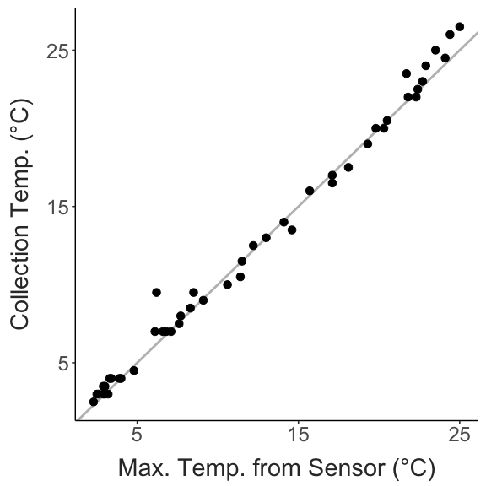

Supp. Figure 1 - Match between collection temperature and continuous temperature data.

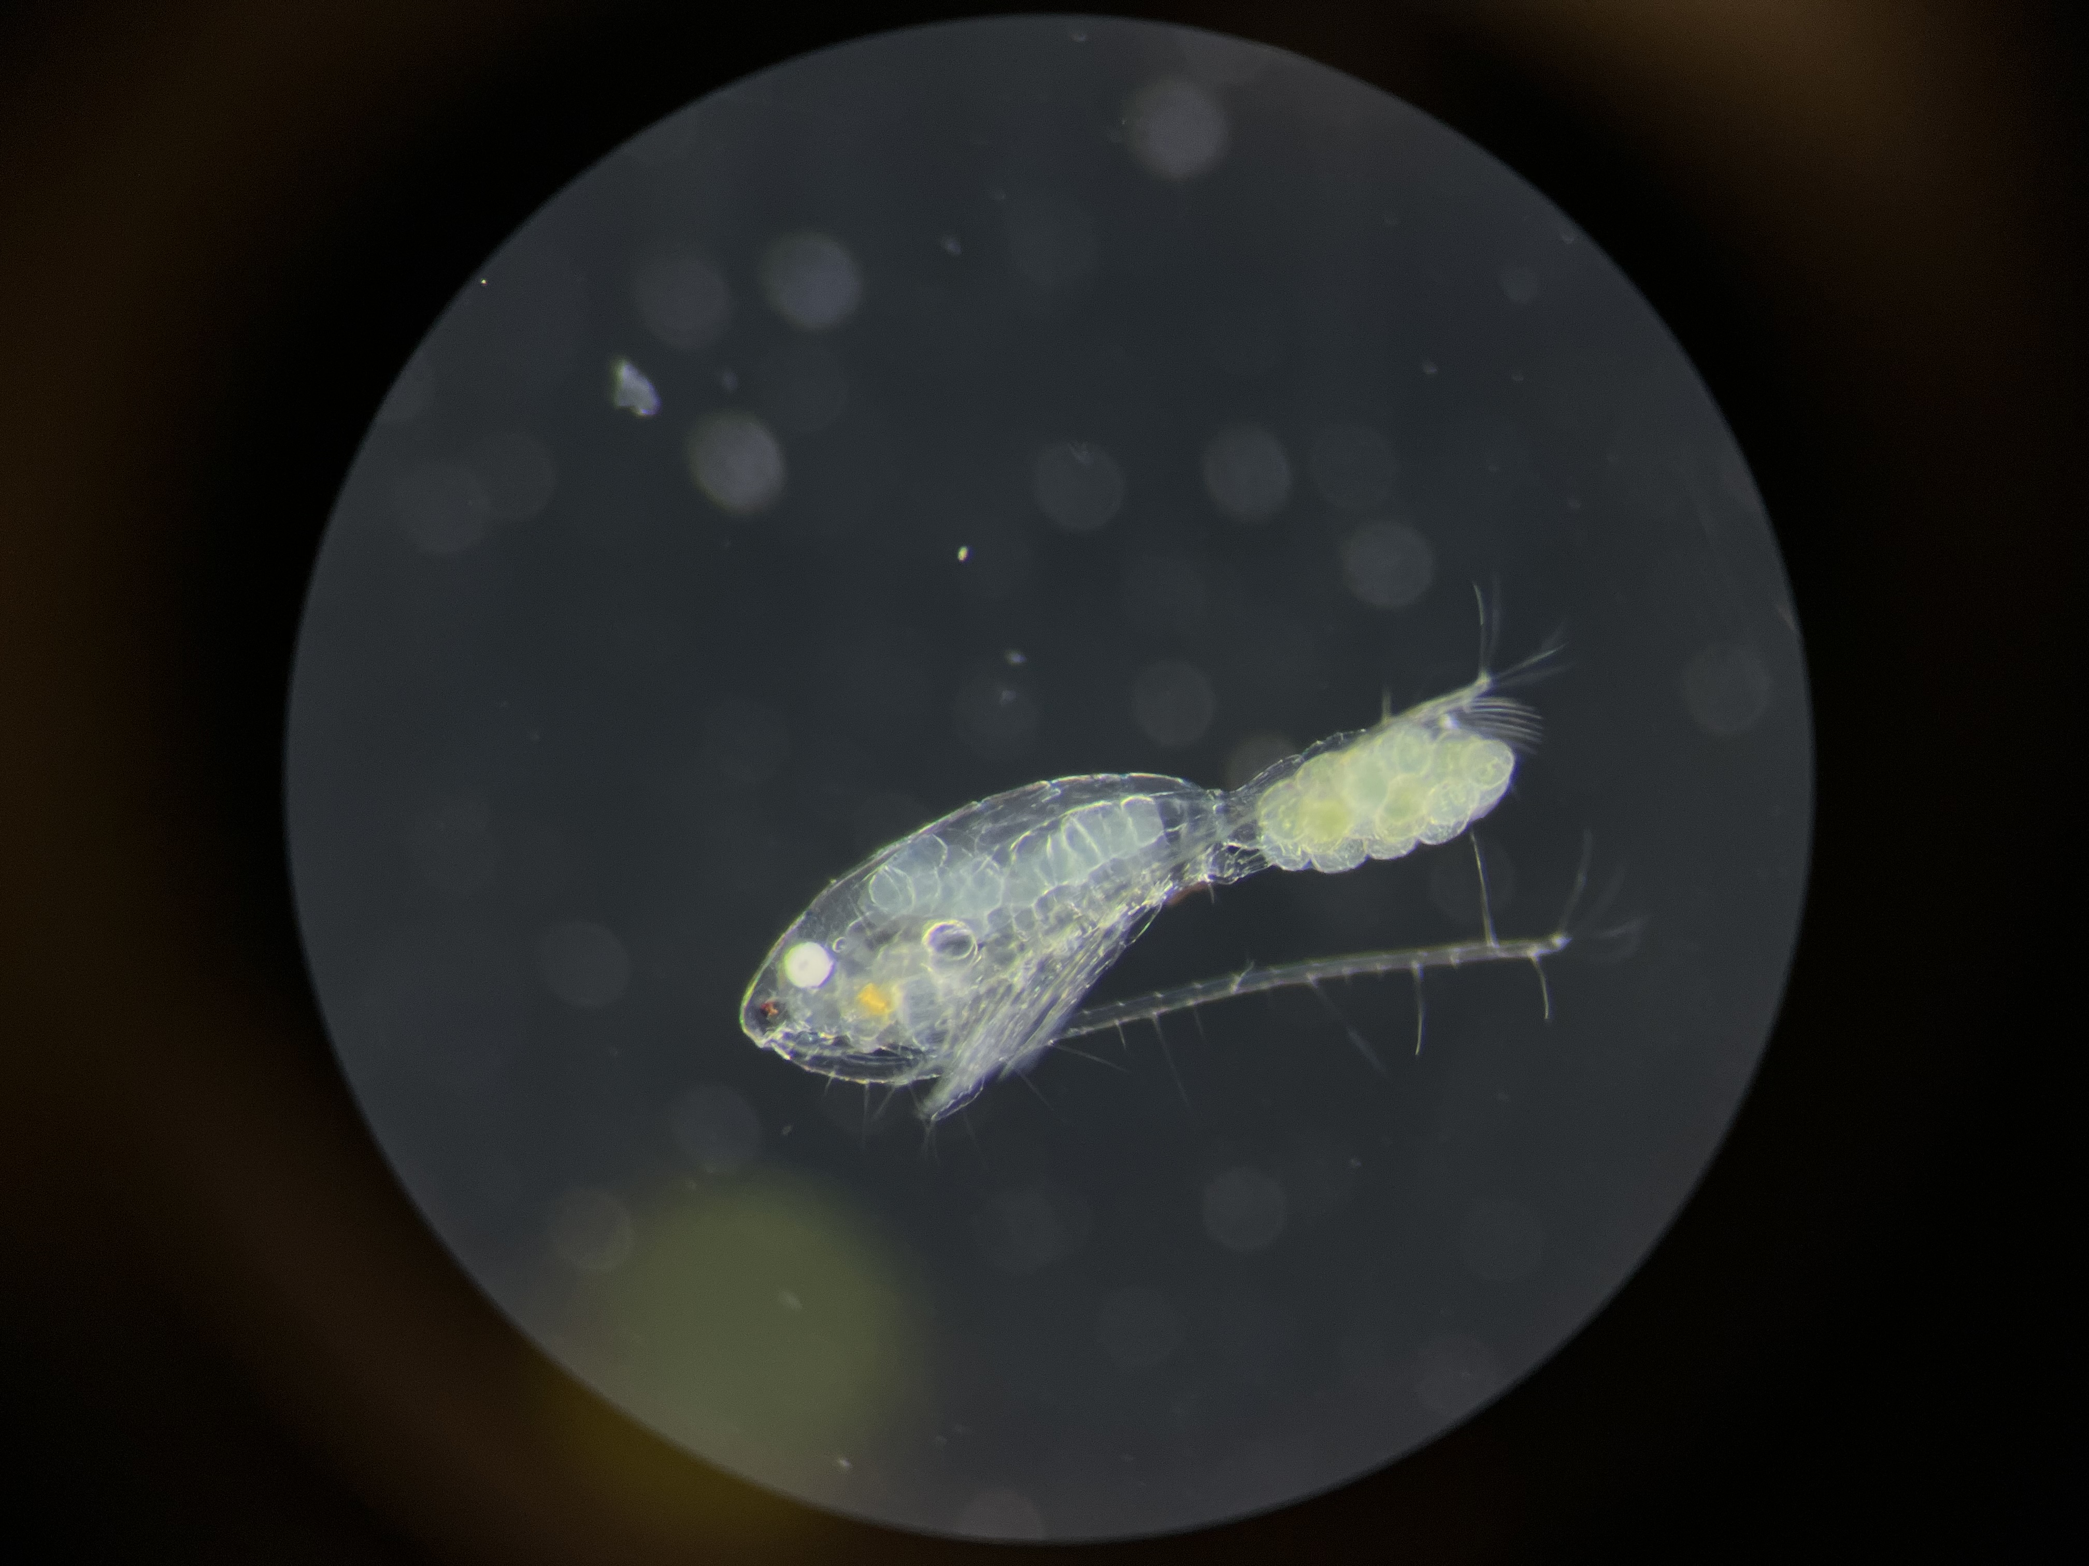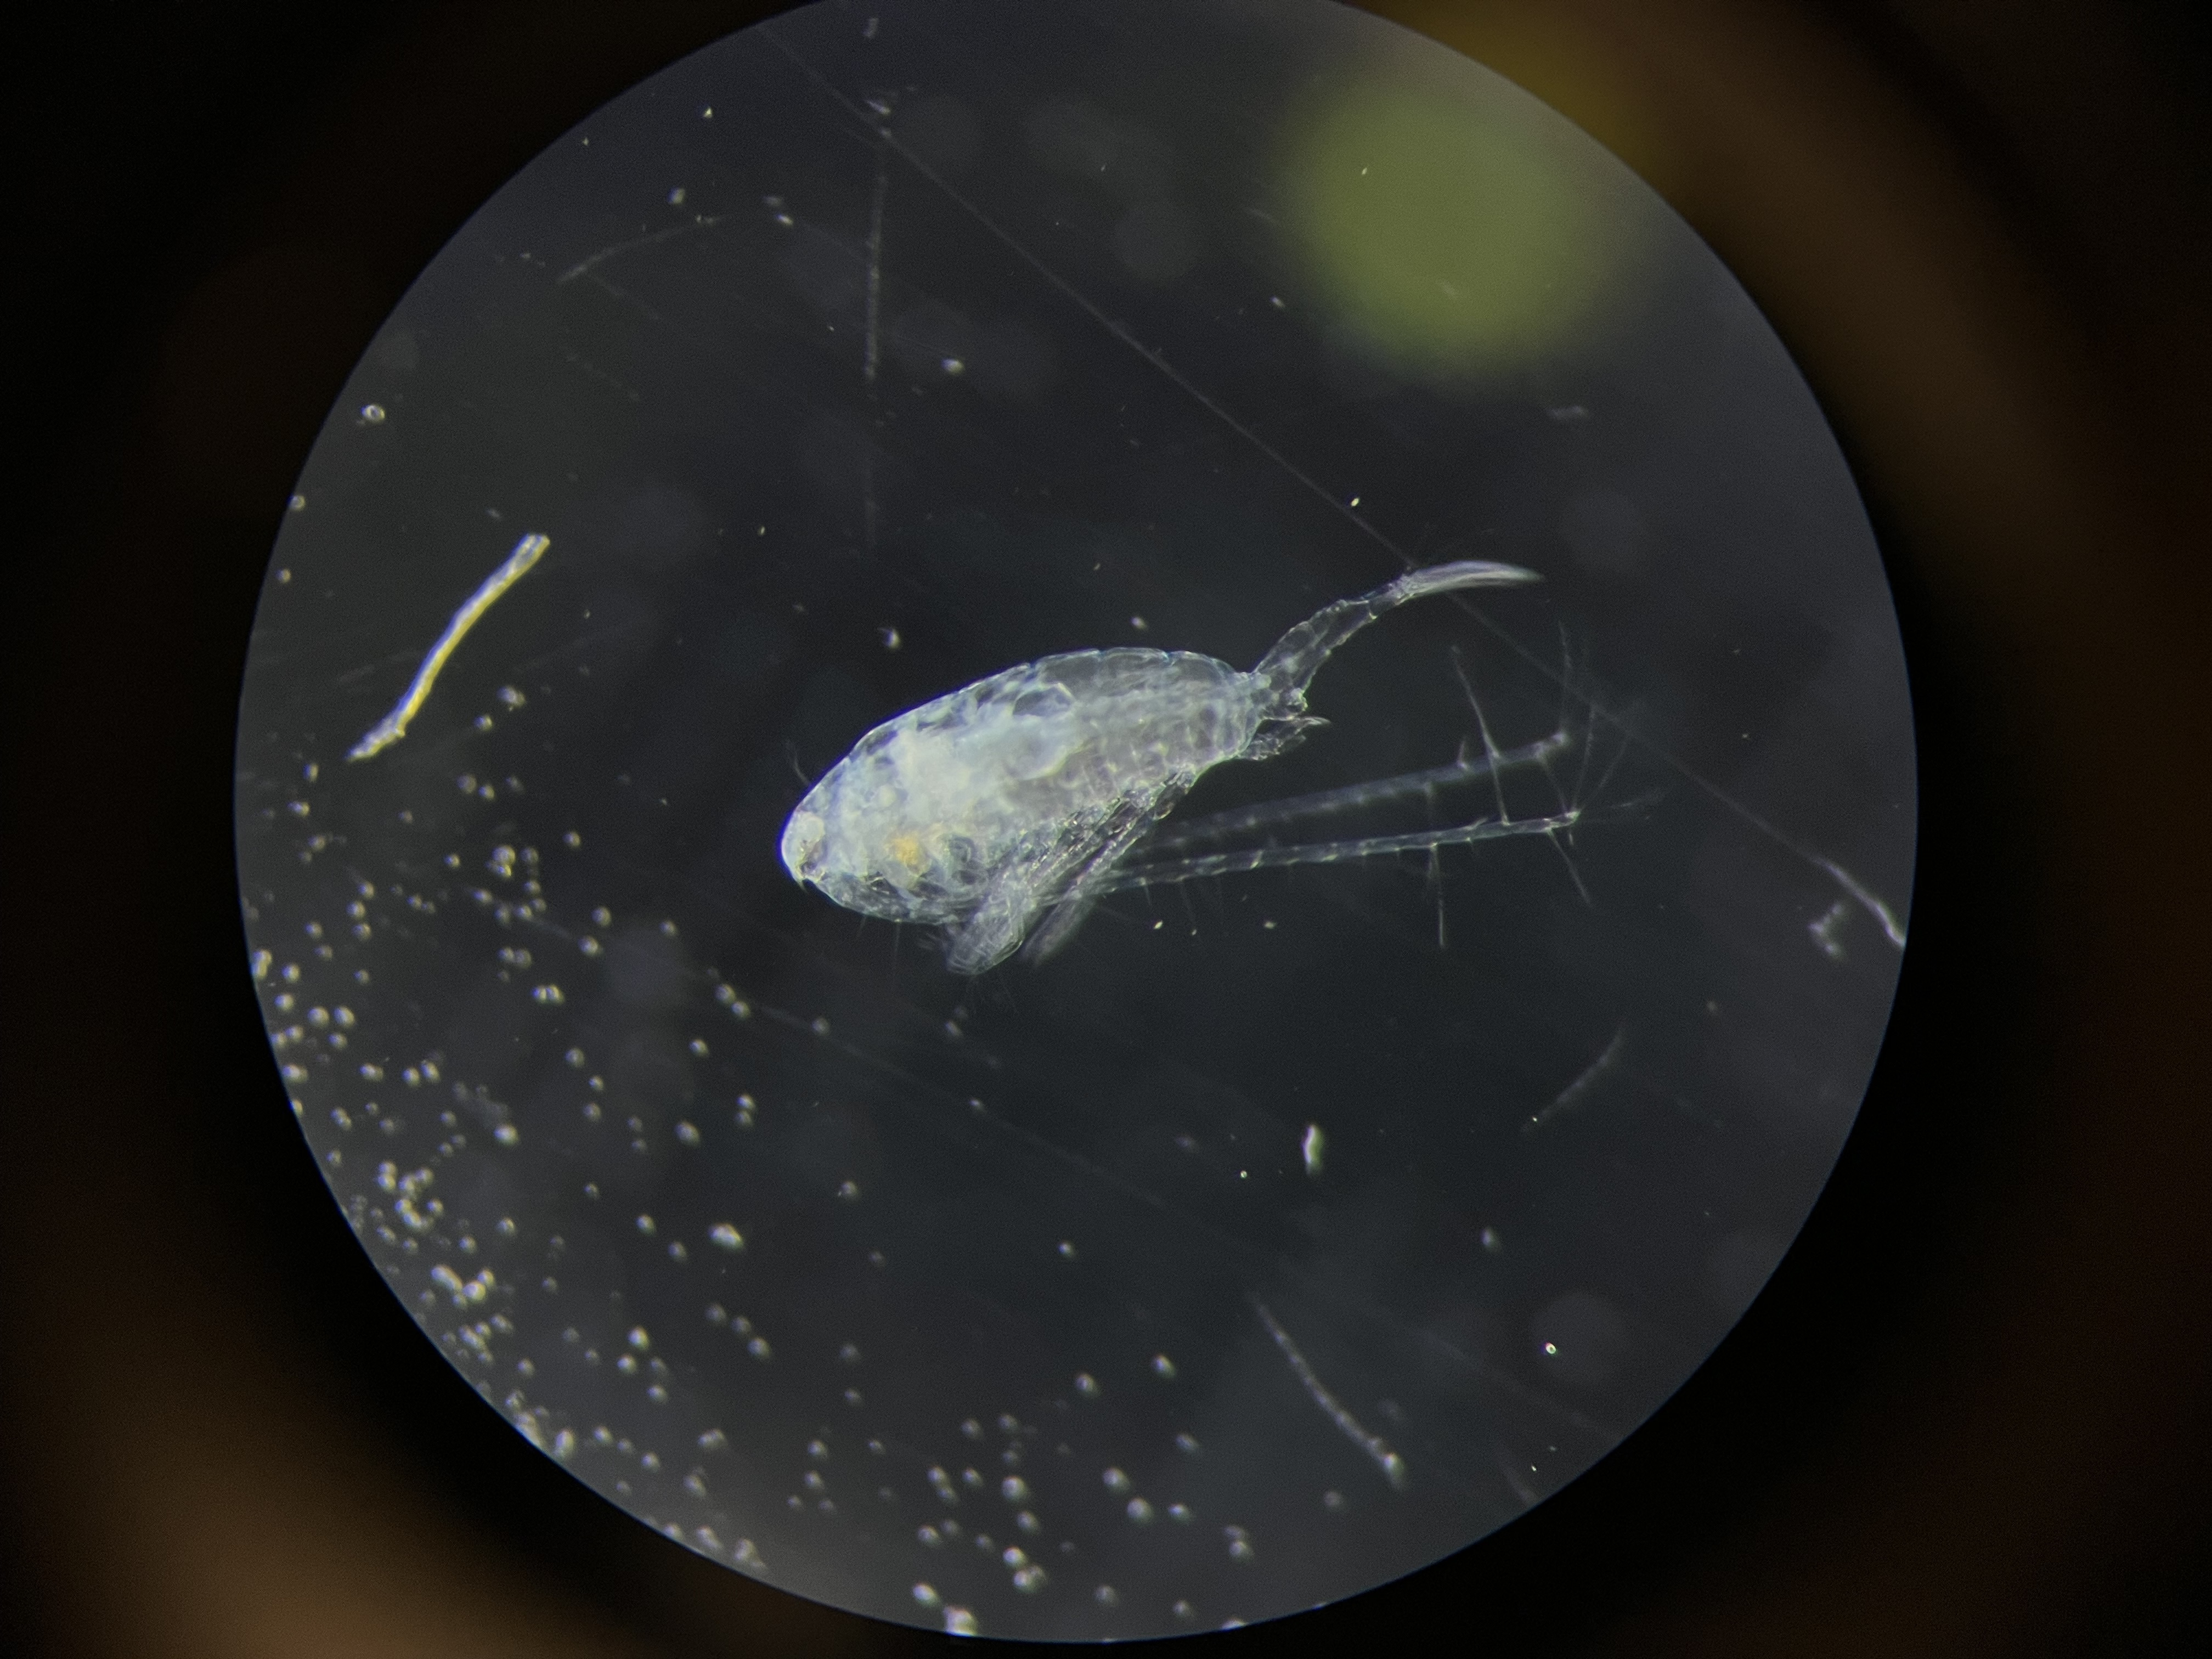

Supp. Figure 2 – Images of copepods with the ‘spot’ and ‘cloudy’ pathogen phenotypes. All other phenotypes are grouped together in ‘other’.

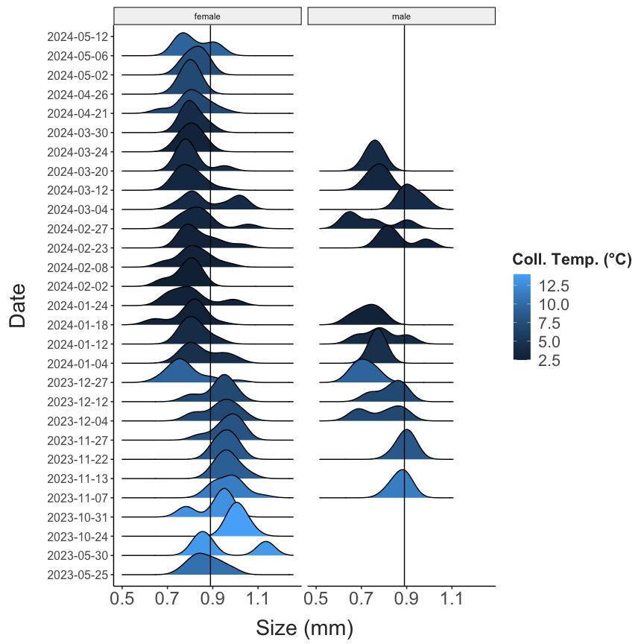

Supp. Figure 3 - L. sicilis size distributions

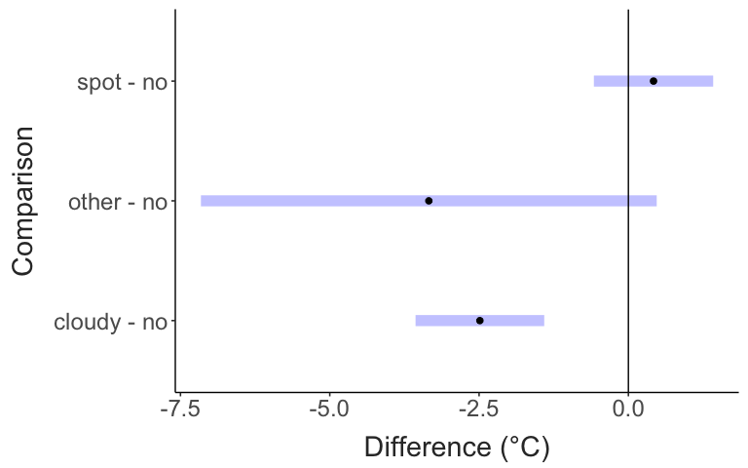

Supp. Figure 4 - Pathogen effect sizes

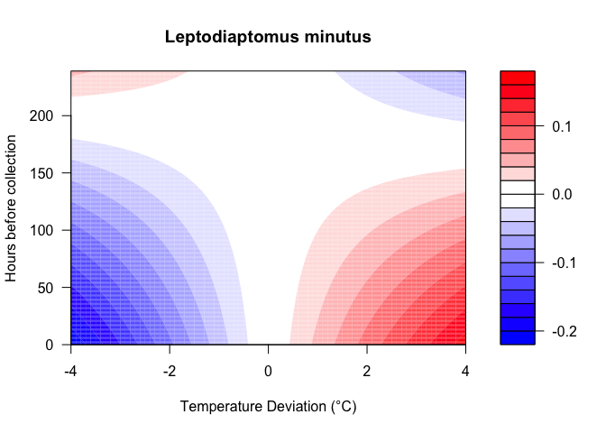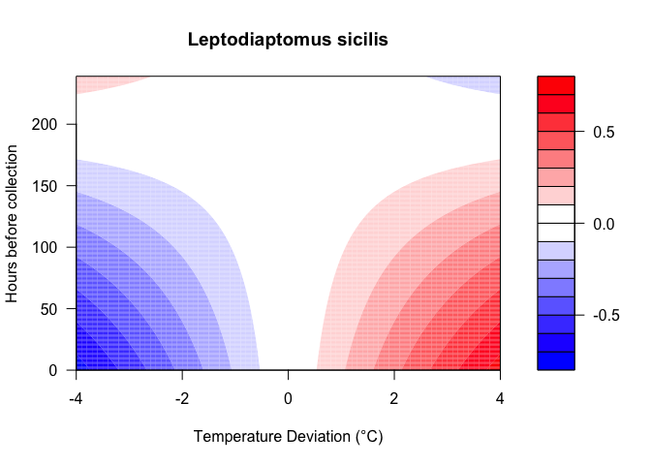

Supp. Figure 5 – Response surfaces from the distributed lag non-linear model showing the deviation of CTmax (color of the shading) as a result of temperature deviation (x-axis) and the time before collection (y-axis), for the two *Leptodiaptomus* species.

**References**

Ardelan, Andre, Anne Tsai, Sophia Will, Rosa McGuire, and Priyanga Amarasekare. 2023. “Increase in Heat Tolerance Following a Period of Heat Stress in a Naturally Occurring Insect Species.” *Journal of Animal Ecology* 92 (10): 2039–51. <https://doi.org/10.1111/1365-2656.13995>.

Bergland, Alan O., Emily L. Behrman, Katherine R. O’Brien, Paul S. Schmidt, and Dmitri A. Petrov. 2014. “Genomic Evidence of Rapid and Stable Adaptive Oscillations over Seasonal Time Scales in Drosophila.” *PLOS Genetics* 10 (11): e1004775. <https://doi.org/10.1371/journal.pgen.1004775>.

Bonadonna, Christine C., Emma R. Moffett, and Celia C. Symons. 2025. “Investigating the Effects of Thermal Variability and Heatwaves on Pond Zooplankton Communities and Physiological Traits.” *Freshwater Biology* 70 (1): e14372. <https://doi.org/10.1111/fwb.14372>.

Branford, Suzanne, Ian Duggan, Ian Hogg, and Gerd-Oltmann Brandorff. 2017. “Mitochondrial DNA Indicates Different North American East Coast Origins for New Zealand and German Invasions of Skistodiaptomus Pallidus (Copepoda: Calanoida).” *Aquatic Invasions* 12 (2): 167–75. <https://doi.org/10.3391/ai.2017.12.2.05>.

Bujan, Jelena, Karl A. Roeder, Stephen P. Yanoviak, and Michael Kaspari. 2020. “Seasonal Plasticity of Thermal Tolerance in Ants.” *Ecology* 101 (6): e03051. <https://doi.org/10.1002/ecy.3051>.

Calosi, Piero, David T Bilton, and John I Spicer. 2007. “Thermal Tolerance, Acclimatory Capacity and Vulnerability to Global Climate Change.” *Biology Letters* 4 (1): 99–102. <https://doi.org/10.1098/rsbl.2007.0408>.

Campbell, Max D., David S. Schoeman, William Venables, Rana Abu-Alhaija, Sonia D. Batten, Sanae Chiba, Frank Coman, et al. 2021. “Testing Bergmann’s Rule in Marine Copepods.” *Ecography* 44 (9): 1283–95. <https://doi.org/10.1111/ecog.05545>.

Cavaletto, Joann F., Henry A. Vanderploeg, and Wayne S. Gardner. 1989. “Wax Esters in Two Species of Freshwater Zooplankton.” *Limnology and Oceanography* 34 (4): 785–89. <https://doi.org/10.4319/lo.1989.34.4.0785>.

Chiapella, Ariana M, Haley Grigel, Hannah Lister, Allison Hrycik, Brian P O’Malley, and Jason D Stockwell. 2021. “A Day in the Life of Winter Plankton: Under-Ice Community Dynamics During 24 h in a Eutrophic Lake.” Edited by Beatrix E Beisner. *Journal of Plankton Research* 43 (6): 865–83. <https://doi.org/10.1093/plankt/fbab061>.

Corona, Stefano, Andrew G. Hirst, David Atkinson, Jasmin Renz, Maarten Boersma, and Angus Atkinson. 2024. “Long-Term Shifts in Phenology, Thermal Niche, Population Size, and Their Interactions in Marine Pelagic Copepods.” *Limnology and Oceanography* 69 (3): 482–97. <https://doi.org/10.1002/lno.12499>.

De Lisle, Stephen P, and Locke Rowe. 2023. “Condition Dependence and the Paradox of Missing Plasticity Costs.” *Evolution Letters* 7 (2): 67–78. <https://doi.org/10.1093/evlett/qrad009>.

Diamond, Sarah E., and Ryan A. Martin. 2016. “The Interplay Between Plasticity and Evolution in Response to Human-Induced Environmental Change.” *F1000Research* 5 (December): 2835. <https://doi.org/10.12688/f1000research.9731.1>.

Dinh, Khuong V., Dania Albini, James A. Orr, Samuel J. Macaulay, Matthias C. Rillig, Katrine Borgå, and Michelle C. Jackson. 2023. “Winter Is Coming: Interactions of Multiple Stressors in Winter and Implications for the Natural World.” *Global Change Biology* 29 (24): 6834–45. <https://doi.org/10.1111/gcb.16956>.

Dowd, W. Wesley, and Mark W. Denny. 2020. “A Series of Unfortunate Events: Characterizing the Contingent Nature of Physiological Extremes Using Long-Term Environmental Records.” *Proceedings of the Royal Society B: Biological Sciences* 287 (1918): 20192333. <https://doi.org/10.1098/rspb.2019.2333>.

Eliassen, Lasse Krøger, Even Sletteng Garvang, Tom Andersen, Erik Engseth, Kåre Andre Kristiansen, Jannicke Wiik-Nielsen, and Josefin Titelman. 2024. “Conspicuous Parasite Modifies Appearance and Energetics of a Marine Copepod.” *ICES Journal of Marine Science* 81 (10): 2052–64. <https://doi.org/10.1093/icesjms/fsae150>.

Fitzgerald, Jacquelyn L., Katharine L. Stuble, Lauren M. Nichols, Sarah E. Diamond, Thomas R. Wentworth, Shannon L. Pelini, Nicholas J. Gotelli, Nathan J. Sanders, Robert R. Dunn, and Clint A. Penick. 2021. “Abundance of Spring- and Winter-Active Arthropods Declines with Warming.” *Ecosphere* 12 (4): e03473. <https://doi.org/10.1002/ecs2.3473>.

Fox, Rebecca J., Jennifer M. Donelson, Celia Schunter, Timothy Ravasi, and Juan D. Gaitán-Espitia. 2019. “Beyond Buying Time: The Role of Plasticity in Phenotypic Adaptation to Rapid Environmental Change.” *Philosophical Transactions of the Royal Society B: Biological Sciences* 374 (1768): 20180174. <https://doi.org/10.1098/rstb.2018.0174>.

García, Francisca C., Eslam O. Osman, Neus Garcias-Bonet, Nathalia Delgadillo-Ordoñez, Erika P. Santoro, Inês Raimundo, Helena D. M. Villela, Christian R. Voolstra, and Raquel S. Peixoto. 2024. “Seasonal Changes in Coral Thermal Threshold Suggest Species-Specific Strategies for Coping with Temperature Variations.” *Communications Biology* 7 (1): 1680. <https://doi.org/10.1038/s42003-024-07340-w>.

Garton, David W., David J. Berg, and Robert J. Fletcher. 1990. “Thermal Tolerances of the Predatory Cladocerans *Bythotrephes Cederstroemi* and *Leptodora Kindti* : Relationship to Seasonal Abundance in Western Lake Erie.” *Canadian Journal of Fisheries and Aquatic Sciences* 47 (4): 731–38. <https://doi.org/10.1139/f90-083>.

Gunderson, Alex R., and Jonathon H. Stillman. 2015. “Plasticity in Thermal Tolerance Has Limited Potential to Buffer Ectotherms from Global Warming.” *Proceedings of the Royal Society B: Biological Sciences* 282 (1808): 20150401. <https://doi.org/10.1098/rspb.2015.0401>.

Gutierrez-Aguirre, M A, and E Suárez-Morales. 1999. “The Freshwater Centropagid Osphranticum Labronectum Forbes, 1882 Subspecies.” *Proceedings of The Biological Society of Washington* 112: 687–94. <http://biostor.org/reference/74264>.

Hahn, Alexandra, and Reid S. Brennan. 2024. “Phenotypic Plasticity Drives Seasonal Thermal Tolerance in a Baltic Copepod.” *Journal of Experimental Marine Biology and Ecology* 576 (July): 152014. <https://doi.org/10.1016/j.jembe.2024.152014>.

Hampton, Stephanie E., Aaron W. E. Galloway, Stephen M. Powers, Ted Ozersky, Kara H. Woo, Ryan D. Batt, Stephanie G. Labou, et al. 2017. “Ecology Under Lake Ice.” Edited by James Grover. *Ecology Letters* 20 (1): 98–111. <https://doi.org/10.1111/ele.12699>.

Haque, Md Tangigul, Shatabdi Paul, Marie E. Herberstein, and Md Kawsar Khan. 2025. “Seasonal Plasticity of Thermal Tolerance Indicates Resilience to Future Climate in Australian Damselflies.” *Oecologia* 207 (7): 109. <https://doi.org/10.1007/s00442-025-05745-w>.

Harada, Tetsuo, Mitsuru Nakajo, Takahiro Furuki, Noritomo Umamoto, Masatoshi Moku, Takero Sekimoto, and Chihiro Katagiri. 2018. “Seasonal Change in Distribution and Heat Coma Temperature of Oceanic Skaters, Halobates (Insecta, Heteroptera: Gerridae).” *Insects* 9 (4): 133. <https://doi.org/10.3390/insects9040133>.

Hernández-Carrasco, Daniel, Jason M. Tylianakis, David A. Lytle, and Jonathan D. Tonkin. 2025. “Ecological and Evolutionary Consequences of Changing Seasonality.” *Science* 388 (6750): eads4880. <https://doi.org/10.1126/science.ads4880>.

Herzig, Alois, R. Stewart Anderson, and David W. Mayhood. 1980. “Production and Population Dynamics of Leptodiaptomus Sicilis in a Mountain Lake in Alberta, Canada.” *Ecography* 3 (1): 50–63. <https://doi.org/10.1111/j.1600-0587.1980.tb00708.x>.

Hopkin, Richard S., Suhaila Qari, Kenneth Bowler, David Hyde, and Mirela Cuculescu. 2006. “Seasonal Thermal Tolerance in Marine Crustacea.” *Journal of Experimental Marine Biology and Ecology* 331 (1): 74–81. <https://doi.org/10.1016/j.jembe.2005.10.007>.

Houghton, David C., and Logan Shoup. 2014. “Seasonal Changes in the Critical Thermal Maxima of Four Species of Aquatic Insects (Ephemeroptera, Trichoptera).” *Environmental Entomology* 43 (4): 1059–66. <https://doi.org/10.1603/EN13344>.

Hu, Xing Ping, and Arthur G. Appel. 2004. “Seasonal Variation of Critical Thermal Limits and Temperature Tolerance in Formosan and Eastern Subterranean Termites (Isoptera: Rhinotermitidae).” *Environmental Entomology* 33 (2): 197–205. <https://doi.org/10.1603/0046-225x-33.2.197>.

Huey, Raymond B, and Lauren B Buckley. 2022. “Designing a Seasonal Acclimation Study Presents Challenges and Opportunities.” *Integrative Organismal Biology* 4 (1): obac016. <https://doi.org/10.1093/iob/obac016>.

Inouye, David W. 2022. “Climate Change and Phenology.” *WIREs Climate Change* 13 (3). <https://doi.org/10.1002/wcc.764>.

Jacob, Staffan, and Delphine Legrand. 2021. “Phenotypic Plasticity Can Reverse the Relative Extent of Intra- and Interspecific Variability Across a Thermal Gradient.” *Proceedings of the Royal Society B: Biological Sciences* 288 (1953): 20210428. <https://doi.org/10.1098/rspb.2021.0428>.

Juan, Carlos de, Kaiene Griffell, Albert Calbet, and Enric Saiz. 2023. “Multigenerational Physiological Compensation and Body Size Reduction Dampen the Effects of Warming on Copepods.” *Limnology and Oceanography* 68 (5): 1037–47. <https://doi.org/10.1002/lno.12327>.

Kelley, A. L. 2014. “The Role Thermal Physiology Plays in Species Invasion.” *Conservation Physiology* 2 (1): cou045–45. <https://doi.org/10.1093/conphys/cou045>.

Khaliq, Imran, Christian Rixen, Florian Zellweger, Catherine H. Graham, Martin M. Gossner, Ian R. McFadden, Laura Antão, et al. 2024. “Warming Underpins Community Turnover in Temperate Freshwater and Terrestrial Communities.” *Nature Communications* 15 (1): 1921. <https://doi.org/10.1038/s41467-024-46282-z>.

Kraemer, Benjamin M., Rachel M. Pilla, R. Iestyn Woolway, Orlane Anneville, Syuhei Ban, William Colom-Montero, Shawn P. Devlin, et al. 2021. “Climate Change Drives Widespread Shifts in Lake Thermal Habitat.” *Nature Climate Change* 11 (6): 521–29. <https://doi.org/10.1038/s41558-021-01060-3>.

Kraskura, Krista, Claire E. Anderson, and Erika J. Eliason. 2024. “Pairing Lab and Field Studies to Predict Thermal Performance of Wild Fish.” *Journal of Thermal Biology* 119 (January): 103780. <https://doi.org/10.1016/j.jtherbio.2023.103780>.

Lai, H. C. 1977. “Changes in Cephalothorax Length of Diaptomus Oregonensis as an Indicator of Generations.” *Hydrobiologia* 54 (1): 17–21. <https://doi.org/10.1007/BF00018767>.

LaMay, Mark, Erin Hayes-Pontius, Ian M Ater, and Timothy B Mihuc. 2013. “A Revised Key to the Zooplankton of Lake Champlain.” *Scientia Discipulorum* 6.

Leclair, Alexandra T A, D Andrew R Drake, Thomas C Pratt, and Nicholas E Mandrak. 2020. “Seasonal Variation in Thermal Tolerance of Redside Dace Clinostomus Elongatus.” *Conservation Physiology* 8 (1): coaa081. <https://doi.org/10.1093/conphys/coaa081>.

Lenth, Russell. 2025. “Emmeans: Estimated Marginal Means, Aka Least-Squares Means.” <https://rvlenth.github.io/emmeans/>.

Lovell, Rebecca S. L., Sinead Collins, Simon H. Martin, Alex L. Pigot, and Albert B. Phillimore. 2023. “Space-for-Time Substitutions in Climate Change Ecology and Evolution.” *Biological Reviews* 98 (6): 2243–70. <https://doi.org/10.1111/brv.13004>.

Malchoff, M., J. Ellen Marsden, and M. Hauser. 2005. “Feasibility of Champlain Canal Aquatic Nuisance Species Barrier Options.”

Martin, Paul R., and Cameron K. Ghalambor. 2023. “A Case for the Competitive Exclusion-Tolerance Rule as a General Cause of Species Turnover Along Environmental Gradients.” *The American Naturalist* 202 (1): 1–17. <https://doi.org/10.1086/724683>.

Mauchline, J. 1998. *The Biology of Calanoid Copepods*. Vol. 33. Advances in Marine Biology. Academic Press, San Diego.

McGinty, Niall, Andrew D. Barton, Zoe V. Finkel, David G. Johns, and Andrew J. Irwin. 2021. “Niche Conservation in Copepods Between Ocean Basins.” *Ecography* 44 (11): 1653–64. <https://doi.org/10.1111/ecog.05690>.

McLean, Matthew, David Mouillot, Aurore A. Maureaud, Tarek Hattab, M. Aaron MacNeil, Eric Goberville, Martin Lindegren, Georg Engelhard, Malin Pinsky, and Arnaud Auber. 2021. “Disentangling Tropicalization and Deborealization in Marine Ecosystems Under Climate Change.” *Current Biology* 31 (21): 4817–4823.e5. <https://doi.org/10.1016/j.cub.2021.08.034>.

Mihuc, Timothy B., Fred Dunlap, Casey Binggeli, Luke Myers, Carrianne Pershyn, Amanda Groves, and Allison Waring. 2012. “Long-Term Patterns in Lake Champlain’s Zooplankton: 1992-2010.” *Journal of Great Lakes Research* 38 (January): 49–57. <https://doi.org/10.1016/j.jglr.2011.08.006>.

Morley, S. A., L. S. Peck, J. M. Sunday, S. Heiser, and A. E. Bates. 2019. “Physiological Acclimation and Persistence of Ectothermic Species Under Extreme Heat Events.” Edited by Adam Algar. *Global Ecology and Biogeography* 28 (7): 1018–37. <https://doi.org/10.1111/geb.12911>.

Muñoz, Martha M., and Jonathan B. Losos. 2018. “Thermoregulatory Behavior Simultaneously Promotes and Forestalls Evolution in a Tropical Lizard.” *The American Naturalist* 191 (1): E15–26. <https://doi.org/10.1086/694779>.

Nasworthy, Kayden C., Anne E. Scofield, and Lars G. Rudstam. 2020. “Feeding Ecology of Limnocalanus Macrurus in the Laurentian Great Lakes.” *Journal of Great Lakes Research* 46 (4): 891–98. <https://doi.org/10.1016/j.jglr.2019.10.011>.

Nowakowski, Kacper, and Łukasz Sługocki. 2024. “Contrasting Responses of Thermocyclops Crassus and T. Oithonoides (Crustacea, Copepoda) to Thermal Stress.” *Scientific Reports* 14 (1): 7660. <https://doi.org/10.1038/s41598-024-58230-4>.

Oliveira, Brunno F., Wendtwoin I. G. Yogo, Daniel A. Hahn, Jiang Yongxing, and Brett R. Scheffers. 2021. “Community-Wide Seasonal Shifts in Thermal Tolerances of Mosquitoes.” *Ecology* 102 (7): e03368. <https://doi.org/10.1002/ecy.3368>.

Orsi, J. J., and T. C. Walter. 1991. “Pseudodiaptomus Forbesi and p. Marinus (Copepoda: Calanoida), the Latest Copepod Immigrants to California’s Sacramento-San Joaquin Estuary.” *Bulletin of the Plankton Society of Japan* Proceedings 4th International Conference on Copepoda: 553562.

Pinsky, Malin L., Anne Maria Eikeset, Douglas J. McCauley, Jonathan L. Payne, and Jennifer M. Sunday. 2019. “Greater Vulnerability to Warming of Marine Versus Terrestrial Ectotherms.” *Nature* 569 (7754): 108–11. <https://doi.org/10.1038/s41586-019-1132-4>.

Pu, Ge, Kirill Shchapov, Nolan J. T. Pearce, Kelly Bowen, Andrew Bramburger, Andrew Camilleri, Hunter Carrick, et al. 2025. “The Great Lakes Winter Grab: Limnological Data from a Multi-Institutional Winter Sampling Campaign on the Laurentian Great Lakes.” *Limnology and Oceanography Letters* 10 (1): 37–61. <https://doi.org/10.1002/lol2.10447>.

Redana, Matteo, Chris Gibbins, and Lesley T. Lancaster. 2024. “Determining Critical Periods for Thermal Acclimatisation Using a Distributed Lag Non-Linear Modelling Approach.” *Ecology and Evolution* 14 (6). <https://doi.org/10.1002/ece3.11451>.

Reid, Janet W. 2007. “Arctodiaptomus Dorsalis (Marsh): A Case History of Copepod Dispersal.” *Banisteria* 30: 3–18.

Rezende, Enrico L., Francisco Bozinovic, András Szilágyi, and Mauro Santos. 2020. “Predicting Temperature Mortality and Selection in Natural Drosophila Populations.” *Science* 369 (6508): 1242–45. <https://doi.org/10.1126/science.aba9287>.

Rezende, Enrico L., Luis E. Castañeda, and Mauro Santos. 2014. “Tolerance Landscapes in Thermal Ecology.” *Functional Ecology* 28 (4): 799–809. <https://doi.org/10.1111/1365-2435.12268>.

Riemer, Kristina, Kristina J. Anderson-Teixeira, Felisa A. Smith, David J. Harris, and S. K. Morgan Ernest. 2018. “Body Size Shifts Influence Effects of Increasing Temperatures on Ectotherm Metabolism.” *Global Ecology and Biogeography* 27 (8): 958–67. <https://doi.org/10.1111/geb.12757>.

Roeder, Karl A., Jelena Bujan, Kirsten M. Beurs, Michael D. Weiser, and Michael Kaspari. 2021. “Thermal Traits Predict the Winners and Losers Under Climate Change: An Example from North American Ant Communities.” *Ecosphere* 12 (7). <https://doi.org/10.1002/ecs2.3645>.

Rohr, Jason R., David J. Civitello, Jeremy M. Cohen, Elizabeth A. Roznik, Barry Sinervo, and Anthony I. Dell. 2018. “The Complex Drivers of Thermal Acclimation and Breadth in Ectotherms.” Edited by Helmut Hillebrand. *Ecology Letters* 21 (9): 1425–39. <https://doi.org/10.1111/ele.13107>.

Rudman, Seth M., Sharon I. Greenblum, Subhash Rajpurohit, Nicolas J. Betancourt, Jinjoo Hanna, Susanne Tilk, Tuya Yokoyama, Dmitri A. Petrov, and Paul Schmidt. 2022. “Direct Observation of Adaptive Tracking on Ecological Time Scales in *Drosophila*.” *Science* 375 (6586): eabj7484. <https://doi.org/10.1126/science.abj7484>.

Sasaki, Matthew C., and Hans G. Dam. 2020. “Genetic Differentiation Underlies Seasonal Variation in Thermal Tolerance, Body Size, and Plasticity in a Short-Lived Copepod.” *Ecology and Evolution* 10 (21): 12200–12210. <https://doi.org/10.1002/ece3.6851>.

Sasaki, Matthew, Jordanna M. Barley, Sarah Gignoux-Wolfsohn, Cynthia G. Hays, Morgan W. Kelly, Alysha B. Putnam, Seema N. Sheth, Andrew R. Villeneuve, and Brian S. Cheng. 2022. “Greater Evolutionary Divergence of Thermal Limits Within Marine Than Terrestrial Species.” *Nature Climate Change* 12 (December): 1175–80. <https://doi.org/10.1038/s41558-022-01534-y>.

Sasaki, Matthew, and Hans G Dam. 2021. “Global Patterns in Copepod Thermal Tolerance.” *Journal of Plankton Research* 43 (4): 598–609. <https://doi.org/10.1093/plankt/fbab044>.

Sasaki, Matthew, Jana Isanta-Navarro, and Lynn Govaert. 2025. “Experimental Ecology and the Balance Between Realism and Feasibility in Aquatic Ecosystems.” *Nature Communications* 16 (1): 5142. <https://doi.org/10.1038/s41467-025-60470-5>.

Sasaki, Matthew, Charles Woods, and Hans G. Dam. 2023. “Parasitism Does Not Reduce Thermal Limits in the Intermediate Host of a Bopyrid Isopod.” *Journal of Thermal Biology* 117 (October): 103712. <https://doi.org/10.1016/j.jtherbio.2023.103712>.

Sayer, Catherine A., Eresha Fernando, Randall R. Jimenez, Nicholas B. W. Macfarlane, Giovanni Rapacciuolo, Monika Böhm, Thomas M. Brooks, et al. 2025. “One-Quarter of Freshwater Fauna Threatened with Extinction.” *Nature* 638 (January): 138–45. <https://doi.org/10.1038/s41586-024-08375-z>.

Schindelin, Johannes, Ignacio Arganda-Carreras, Erwin Frise, Verena Kaynig, Mark Longair, Tobias Pietzsch, Stephan Preibisch, et al. 2012. “Fiji: An Open-Source Platform for Biological-Image Analysis.” *Nature Methods* 9 (7): 676–82. <https://doi.org/10.1038/nmeth.2019>.

Schmalensee, Loke von, Pauline Caillault, Katrín Hulda Gunnarsdóttir, Karl Gotthard, and Philipp Lehmann. 2023. “Seasonal Specialization Drives Divergent Population Dynamics in Two Closely Related Butterflies.” *Nature Communications* 14 (1): 3663. <https://doi.org/10.1038/s41467-023-39359-8>.

Seebacher, Frank, Craig R. White, and Craig E. Franklin. 2015. “Physiological Plasticity Increases Resilience of Ectothermic Animals to Climate Change.” *Nature Climate Change* 5 (1): 61–66. <https://doi.org/10.1038/nclimate2457>.

Smeltzer, Eric, Angela d. Shambaugh, and Pete Stangel. 2012. “Environmental Change in Lake Champlain Revealed by Long-Term Monitoring.” *Journal of Great Lakes Research* 38 (January): 6–18. <https://doi.org/10.1016/j.jglr.2012.01.002>.

Somero, G. N. 2010. “The Physiology of Climate Change: How Potentials for Acclimatization and Genetic Adaptation Will Determine ‘Winners’ and ‘Losers’.” *Journal of Experimental Biology* 213 (6): 912–20. <https://doi.org/10.1242/jeb.037473>.

Stemkovski, Michael, Joey R. Bernhardt, Benjamin Wong Blonder, John B. Bradford, Kyra Clark-Wolf, Laura E. Dee, Margaret E. K. Evans, et al. 2025. “Ecological Acclimation: A Framework to Integrate Fast and Slow Responses to Climate Change.” *Functional Ecology* n/a (n/a). <https://doi.org/10.1111/1365-2435.70079>.

Sullivan, Christopher J., Jordan S. Read, and Gretchen J. A. Hansen. 2025. “Climate-Driven Alterations of Lake Thermal Regimes.” *Limnology and Oceanography*, July. <https://doi.org/10.1002/lno.70128>.

Svetlichny, L., and L. Samchyshyna. 2021. “A New Finding of the Non-Native Copepod Sinodiaptomus Sarsi (Copepoda, Calanoida, Diaptomidae) in Ukraine.” *Zoodiversity* 55 (1): 1–8. <https://doi.org/10.15407/zoo2021.01.001>.

Team, R Core. 2022. *R: A Language and Environment for Statistical Computing*. Vienna, Austria: R Foundation for Statistical Computing. <https://www.R-project.org/>.

Thum, Ryan A., and Alison M. Derry. 2008. “Taxonomic Implications for Diaptomid Copepods Based on Contrasting Patterns of Mitochondrial DNA Sequence Divergences in Four Morphospecies.” *Hydrobiologia* 614 (1): 197–207. <https://doi.org/10.1007/s10750-008-9506-x>.

Ueno, Takahisa, Akiko Takenoshita, Kaiya Hamamichi, Mitsuhiko P. Sato, and Yuma Takahashi. 2023. “Rapid Seasonal Changes in Phenotypes in a Wild Drosophila Population.” *Scientific Reports* 13 (1): 21940. <https://doi.org/10.1038/s41598-023-48571-x>.

Uttieri, M., L. Aguzzi, R. Aiese Cigliano, A. Amato, N. Bojanić, M. Brunetta, E. Camatti, et al. 2020. “WGEUROBUS Working Group “Towards a EURopean OBservatory of the Non-Indigenous Calanoid Copepod Pseudodiaptomus marinUS”.” *Biological Invasions* 22 (3): 885–906. <https://doi.org/10.1007/s10530-019-02174-8>.

Vanderploeg, Henry A., Joann F. Cavaletto, James R. Liebig, and Wayne S. Gardner. 1998. “*Limnocalanus Macrurus* (Copepoda: Calanoida) Retains a Marine Arctic Lipid and Life Cycle Strategy in Lake Michigan.” *Journal of Plankton Research* 20 (8): 1581–97. <https://doi.org/10.1093/plankt/20.8.1581>.

Ward, H. B., and G. C. Whipple. 1959. *Fresh-water biology*. 2nd ed. New York: Wiley.

Wiens, John J., David D. Ackerly, Andrew P. Allen, Brian L. Anacker, Lauren B. Buckley, Howard V. Cornell, Ellen I. Damschen, et al. 2010. “Niche Conservatism as an Emerging Principle in Ecology and Conservation Biology.” *Ecology Letters* 13 (10): 1310–24. <https://doi.org/10.1111/j.1461-0248.2010.01515.x>.

Williams, Caroline M, Gregory J Ragland, Gustavo Betini, Lauren B Buckley, Zachary A Cheviron, Kathleen Donohue, Joe Hereford, et al. 2017. “Understanding Evolutionary Impacts of Seasonality: An Introduction to the Symposium.” *Integrative and Comparative Biology* 57 (5): 921–33. <https://doi.org/10.1093/icb/icx122>.

Winder, Monika, Daniel E. Schindler, Timothy E. Essington, and Arni H. Litt. 2009. “Disrupted Seasonal Clockwork in the Population Dynamics of a Freshwater Copepod by Climate Warming.” *Limnology and Oceanography* 54 (6part2): 2493–2505. <https://doi.org/10.4319/lo.2009.54.6_part_2.2493>.

Woolway, R. Iestyn, Eleanor Jennings, Tom Shatwell, Malgorzata Golub, Don C. Pierson, and Stephen C. Maberly. 2021. “Lake Heatwaves Under Climate Change.” *Nature* 589 (7842): 402–7. <https://doi.org/10.1038/s41586-020-03119-1>.

Woolway, R. Iestyn, Benjamin M. Kraemer, John D. Lenters, Christopher J. Merchant, Catherine M. Reilly, and Sapna Sharma. 2020. “Global Lake Responses to Climate Change.” *Nature Reviews Earth and Environment* 1 (8): 388–403. <https://doi.org/10.1038/s43017-020-0067-5>.